Library Management System
Aim
To design and develop a simple Library Management System website using HTML that helps students search for books and study materials, view borrowing details, check fines, and manage their profiles. It also provides a basic interface for librarians to manage books, issue and return books, calculate fines, and upload study materials.
Source Code
This is a beginner-friendly program using only HTML. Save it as library.html and open it in your browser.
It displays the main features using headings, forms, tables, and links. Since this is HTML only, login, searching, and other operations are not connected to a database.

<!DOCTYPE html>
<html>
<head>
<title>Library Management System</title>
</head>
<body>
<h1>Library Management System</h1>
<p>Welcome to our College Library</p>
<hr>
<h2>User Login</h2>
<form>
Username: <input type="text" placeholder="Enter username"><br><br>
Password: <input type="password" placeholder="Enter password"><br><br>
<input type="submit" value="Login">
</form>
<h2>User Registration</h2>
<form>
Name: <input type="text" placeholder="Enter name"><br><br>
Email: <input type="email" placeholder="Enter email"><br><br>
Password: <input type="password"><br><br>
<input type="submit" value="Register">
</form>
<hr>
<h2>Search Books</h2>
<form>
<input type="text" placeholder="Enter book name">
<input type="submit" value="Search">
</form>
<h3>Available Books</h3>
<table border="1">
<tr>
<th>Book ID</th>
<th>Book Name</th>
<th>Author</th>
<th>Status</th>
</tr>
<tr>
<td>101</td>
<td>Python Programming</td>
<td>Guido van Rossum</td>
<td>Available</td>
</tr>
<tr>
<td>102</td>
<td>Java Programming</td>
<td>James Gosling</td>
<td>Issued</td>
</tr>
<tr>
<td>103</td>
<td>Database Management</td>
<td>Abraham Silberschatz</td>
<td>Available</td>
</tr>
</table>
<h2>My Borrow History</h2>
<table border="1">
<tr>
<th>Book Name</th>
<th>Issue Date</th>
<th>Due Date</th>
<th>Status</th>
</tr>
<tr>
<td>Python Programming</td>
<td>01-10-2026</td>
<td>15-10-2026</td>
<td>Returned</td>
</tr>
<tr>
<td>Java Programming</td>
<td>10-10-2026</td>
<td>24-10-2026</td>
<td>Issued</td>
</tr>
</table>
<h2>My Fine Details</h2>
<p>Fine Amount: Rs. 20</p>
<hr>
<h2>Study Materials</h2>
<form>
Select Year:
<select>
<option>First Year</option>
<option>Second Year</option>
<option>Third Year</option>
<option>Fourth Year</option>
</select>
<br><br>
Select Semester:
<select>
<option>Semester 1</option>
<option>Semester 2</option>
<option>Semester 3</option>
<option>Semester 4</option>
<option>Semester 5</option>
<option>Semester 6</option>
<option>Semester 7</option>
<option>Semester 8</option>
</select>
<br><br>
<input type="submit" value="Search Materials">
</form>
<p>
<a href="study-material.pdf" download>
Download Study Material
</a>
</p>
<hr>
<h2>Librarian Admin</h2>
<h3>Add Book</h3>
<form>
Book ID: <input type="text"><br><br>
Book Name: <input type="text"><br><br>
Author: <input type="text"><br><br>
<input type="submit" value="Add Book">
</form>
<h3>Update or Delete Book</h3>
<form>
Enter Book ID: <input type="text"><br><br>
<input type="submit" value="Update Book">
<input type="reset" value="Delete Book">
</form>
<h3>Issue Book</h3>
<form>
Student ID: <input type="text"><br><br>
Book ID: <input type="text"><br><br>
Issue Date: <input type="date"><br><br>
Due Date: <input type="date"><br><br>
<input type="submit" value="Issue Book">
</form>
<h3>Return Book and Calculate Fine</h3>
<form>
Book ID: <input type="text"><br><br>
Return Date: <input type="date"><br><br>
Fine Amount: <input type="number" placeholder="Enter fine"><br><br>
<input type="submit" value="Update Return Status">
</form>
<h3>Upload Study Material</h3>
<form>
Material Name: <input type="text"><br><br>
Upload File: <input type="file"><br><br>
<input type="submit" value="Upload Material">
</form>
<hr>
<h2>My Profile</h2>
<p>Name: Student</p>
<p>Email: student@example.com</p>
<h2>Contact Us</h2>
<form>
Name: <input type="text"><br><br>
Email: <input type="email"><br><br>
Message:<br>
<textarea rows="4" cols="30"></textarea><br><br>
<input type="submit" value="Send Message">
</form>
<hr>
<p>Library Management System - 2026</p>
</body>
</html>

Output
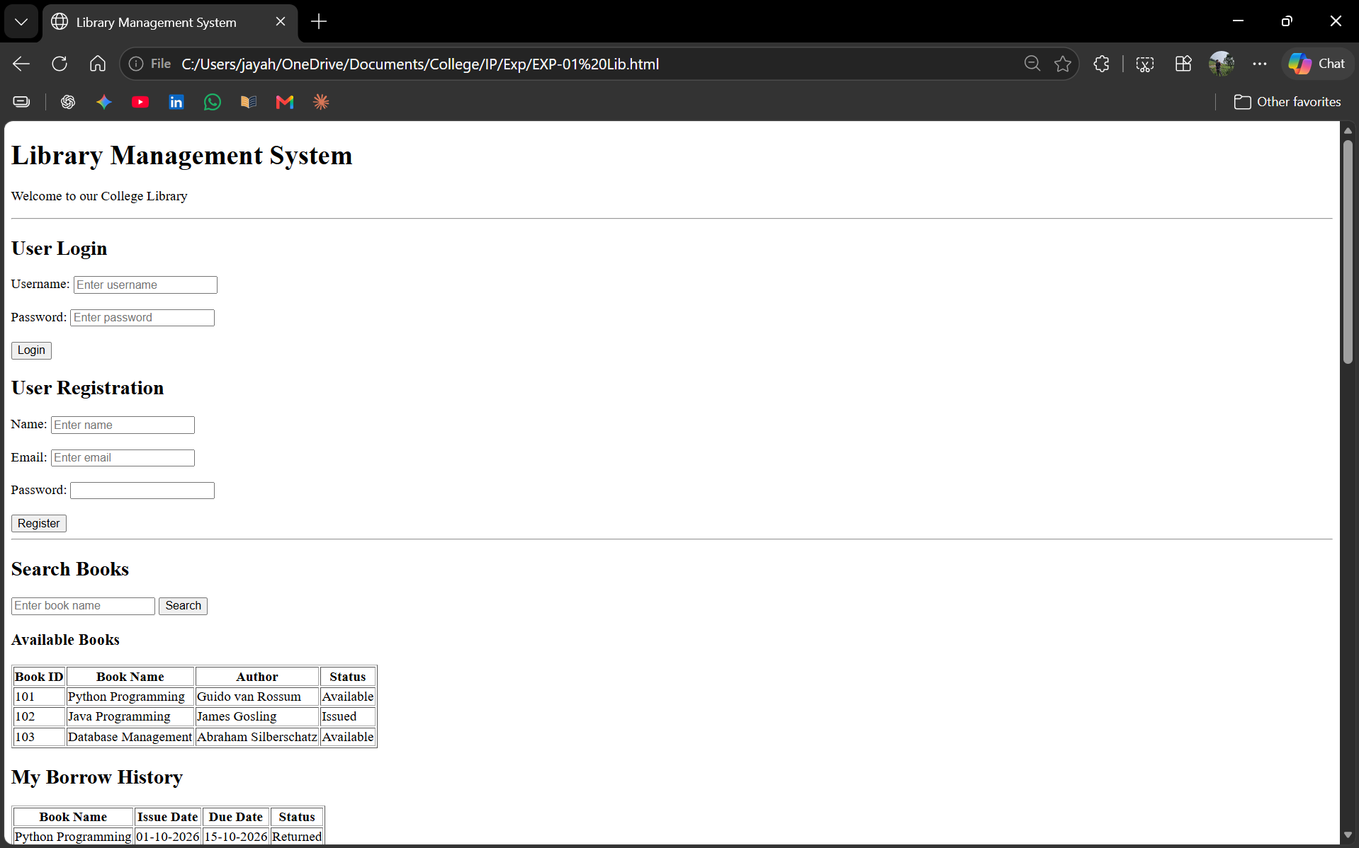

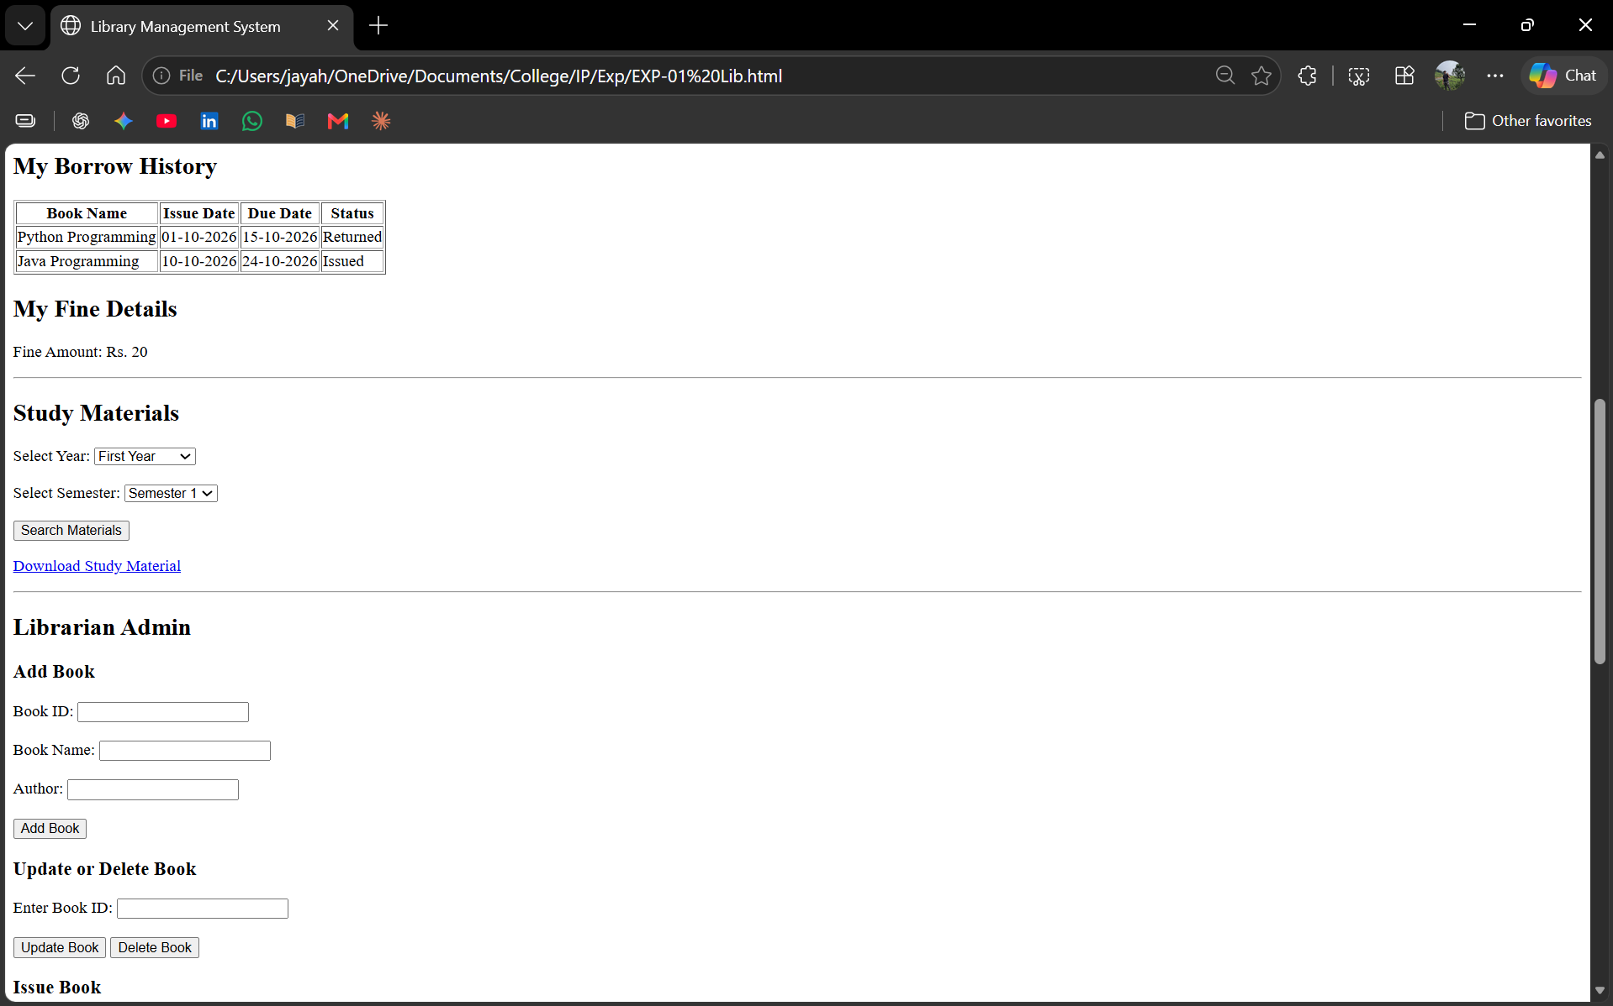
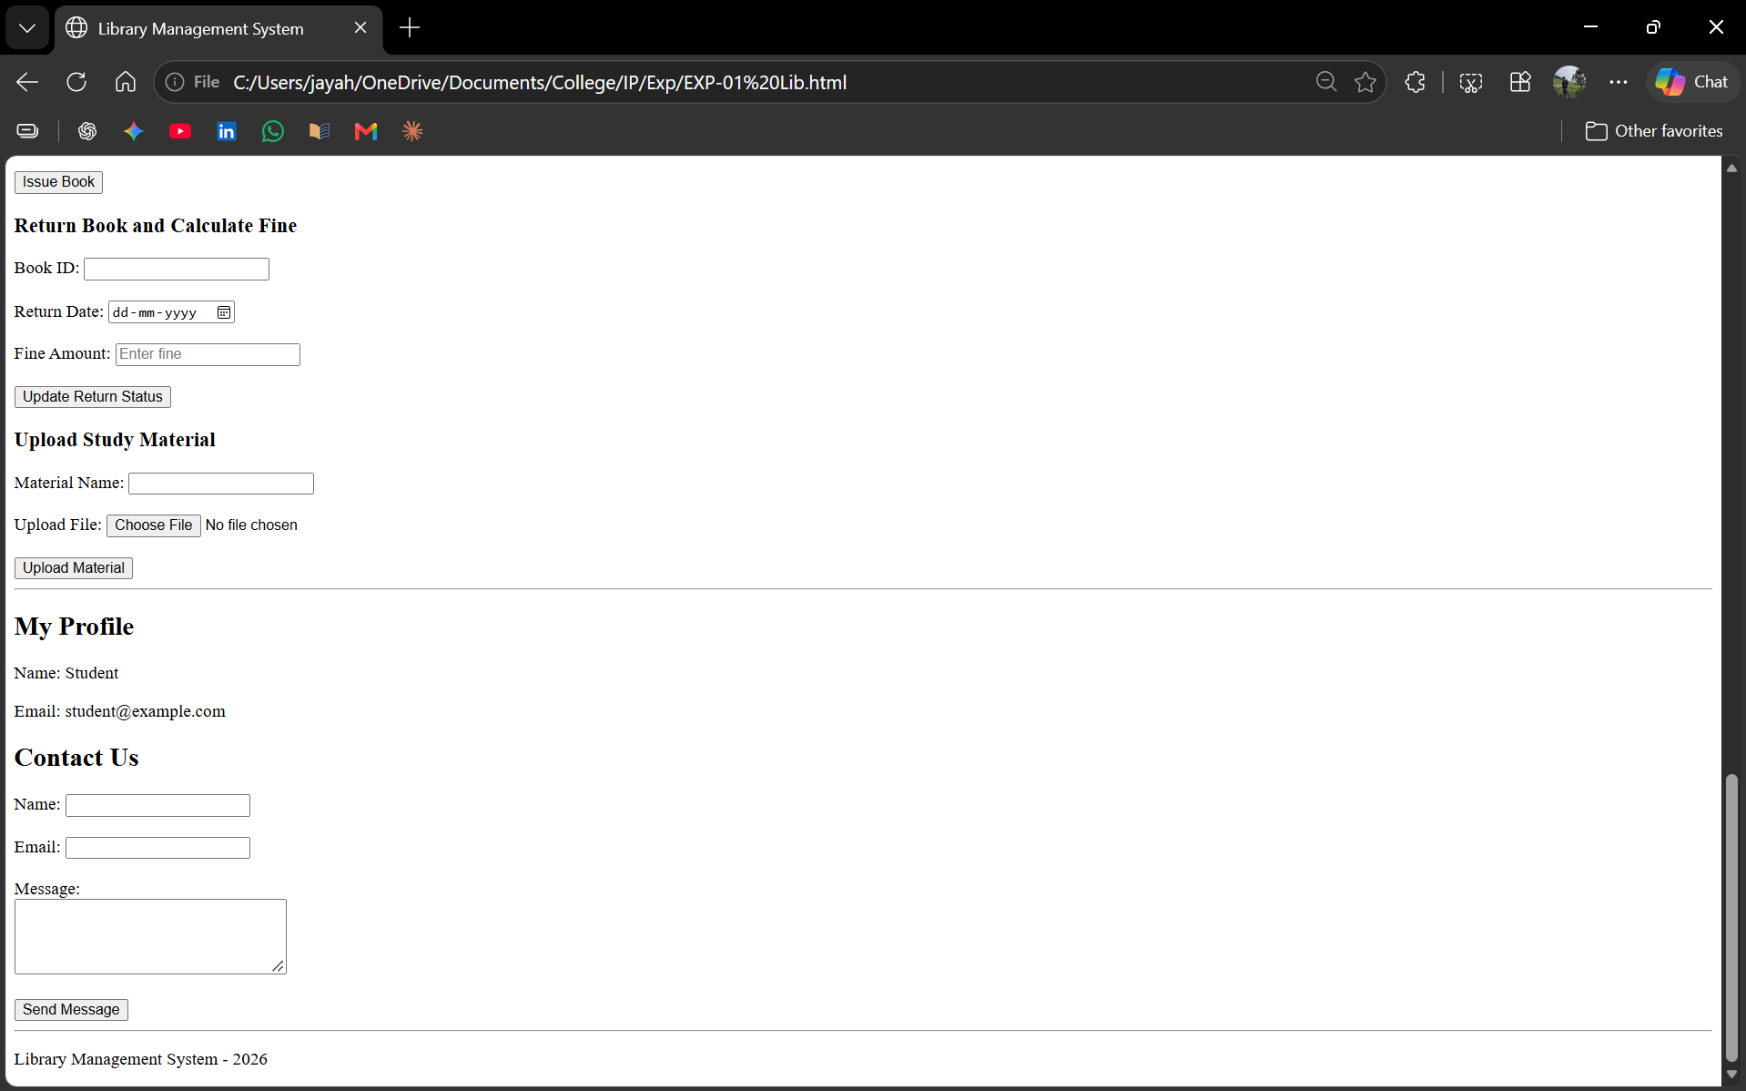

Result
Thus, a basic Library Management System webpage was created successfully using HTML. It demonstrates the essential interface elements required for library operations.

